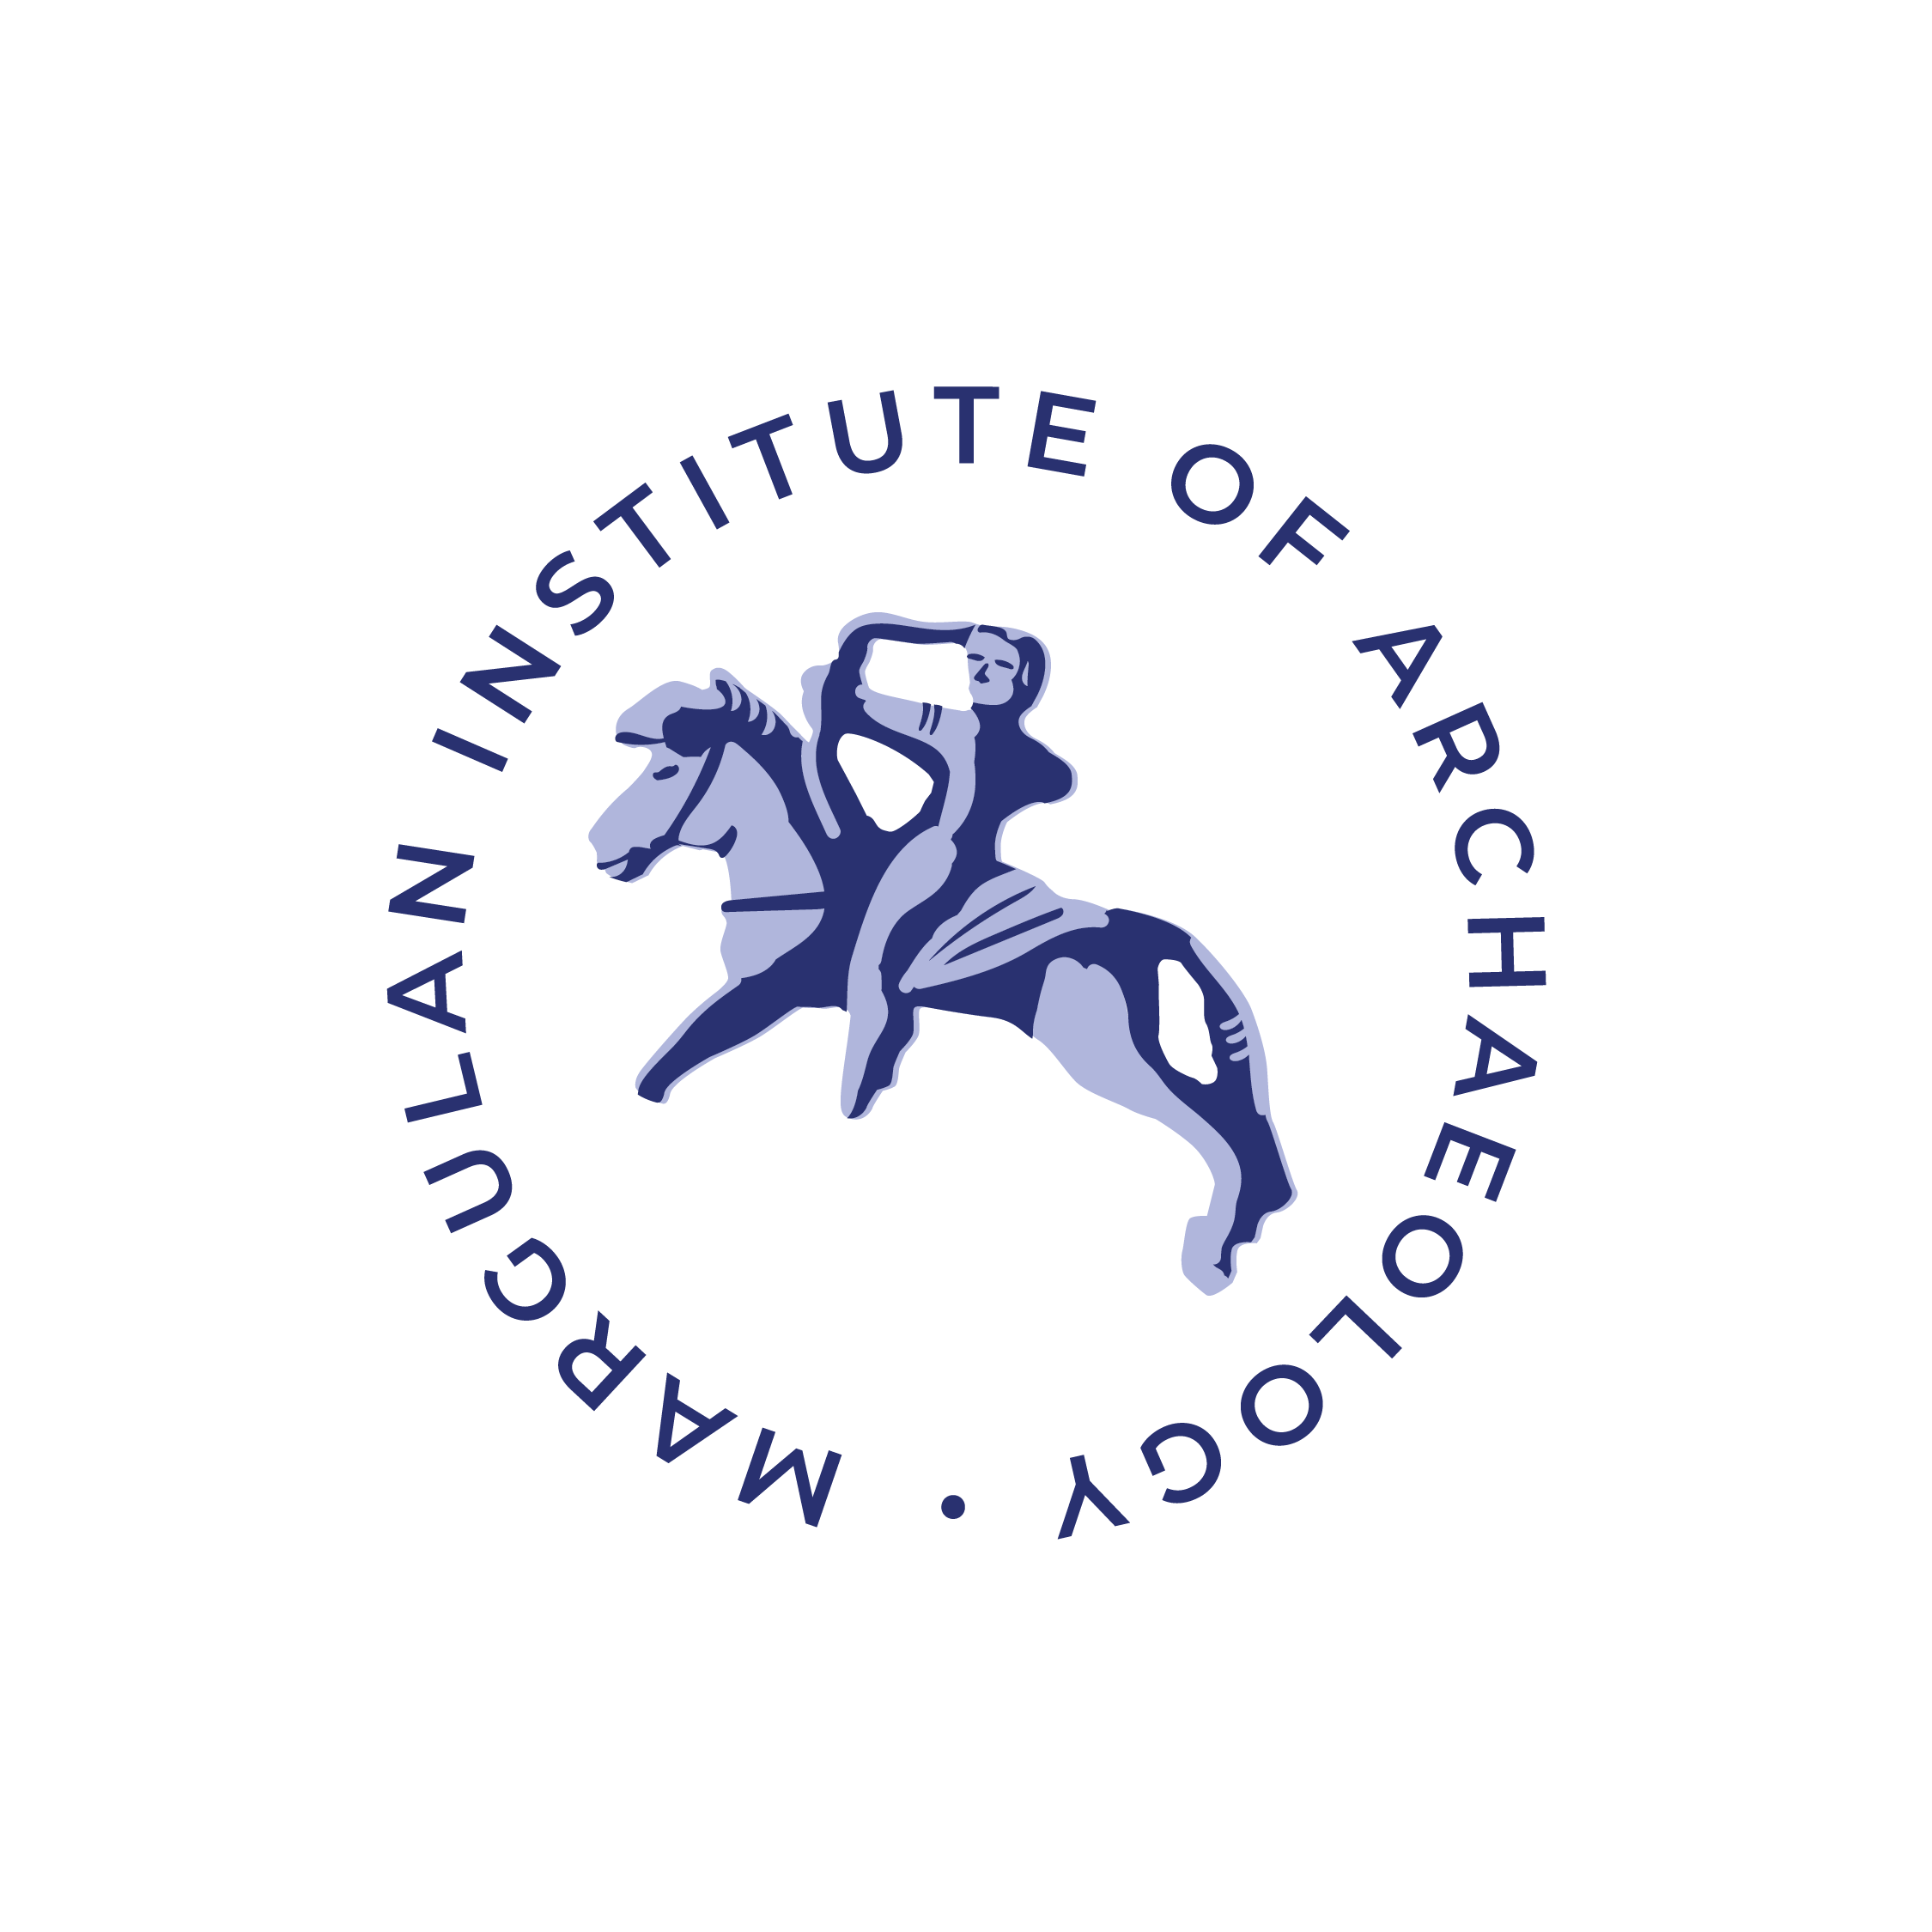
Ministry of Science and Higher Education of the Republic of Kazakhstan
Committee of Science
Margulan Institute of Archaeology

INFORMATION LETTER

Dear colleagues!
We invite you to take part in the traditional International scientific and practical conference "Margulan Readings-2023", which is scheduled for March 30-31, 2023 in Almaty.
The format of the conference provides for hearing and discussing reports on the results of field archaeological research conducted both in 2022 and in previous years, with the materials of which there is a need and desire to familiarize the scientific community. In addition, reports concerning the application of new methods of study, interdisciplinary research of archaeological monuments, their protection and use in various fields of scientific and cultural life are of interest.
Directions of work of the conference:
- Archaeology of Kazakhstan: a history of ideas and research;
- Research of the objects of historical and cultural heritage monuments: new materials and their approbation based on the results of field surveys in 2022;
- Current problems and prospects of studying monuments of the Stone Age;
- The era of early Metal: problems of periodization and cultural identification of complexes;
- Early nomads in the Eurasian cultural space;
- Medieval archaeology: the city and steppe civilization;
- Multidisciplinary approaches in archaeological research: traditional methodology and modern technologies;
- Archaeological monuments of Kazakhstan: problems of preservation and use of historical and cultural heritage.

Working languages of the conference: Kazakh, Russian, English.
FORMATION OF THE PROGRAM AND PUBLICATION OF THE COLLECTION OF ARTICLES:
To compile the conference program, it is necessary to send application forms according to the attached sample by February 28, 2023.
Reports in co-authorship are submitted by one application and the data are reflected in it sequentially separated by semicolons; if the information is repeated (for example, country and/or city, place of work, postal address, etc.), then they do not need to be duplicated:
APPLICATION FORM
of the participant of the scientific and practical conference "Margulan readings–2023"

- Full name of the author;
- Country, city;
- Place of work;
- Position;
- Academic degree, title;
- Title of the report;
- Postal address (with ZIP code), e-mail, contact phone
- Presentation form (oral or poster);
- The presentation form of the report and the necessary technical means.

The collection of articles is planned to be released after the conference.

The previous issue of the collection "Margulan Readings–2022", as well as other publications, are available on the website of the Margulan Archaeology Institute.
URL: https://archaeolog.kz/index.php?option=com_content&view=article&id=550%3A-2022-&catid=6%3Anews&Itemid=2&lang=ru.

Address of the Conference Organizing Committee:
050010, Republic of Kazakhstan, Almaty, Dostyk Ave., 44, Margulan Archaeology Institute CS MSHE RK.
For organizational issues, you can contact the following contact persons:
Loshakova Tatiana, +7 777 564 63 24;
Kasenova Asem, +7 707 518 12 30;
Aminova Rimma, +7 776 207 79 58 .

Applications are accepted by e-mail: margulan_conf@archeo.kz
REQUIREMENTS FOR THE DESIGN OF THE TEXTS OF REPORTS:
1. The surname and initials of the author(s) are indicated on the first page before the title of the article (the lines highlighted in red will be located in the footers). See the design sample:
А. Е. Айтбаева,
Ә. М. Манапова

Айгерім Есімқанқызы Айтбаева¹, aaitbaeva84@mail.ru
Әлия Мерекеқызы Манапова¹, merekeevna@mail.ru
¹Ә.Х. Марғұлан ат. Археология институты, Алматы, Қазақстан

А.Н. Бернштамның өмір жолы мен ғылыми қызметі*

Аннотация. Мақала Қазақстан археология ғылымын ұйымдастырушылардың бірі, еліміздің көптеген ескерткіштерін ашқан, есепке алған әрі алғашқы қазба жүргізген, әртүрлі күрделі тарихи-археологиялық мәселелер бойынша ой-тұжырымдар жасаған А.Н. Бернштамның Қазақстан археология ғылымына қосқан үлесіне арналады. Мақаланы жазу барысында ғалымның өмірі мен шығармашылығын ғана қарастырып қоймай, оның тұлғасының қалыптасуын көрсетуге мүмкіндік беретін библиографиялық (өмірбаяндық) әдіс қолданылды. Мақалада алғаш рет А.Н. Бернштамның өмірбаяны, ғылыми қызметі мен ғылыми мұрасы мұрағат материалдары мен ғалым зерттеулері негізінде толықтай сипатталды. Ғалымның ғылыми қызметі сол кезеңдегі орын алған саяси жағдайлар мен ғылымның дамуымен бірге байланыста қарастырылып, Қазақстан археологиясының қалыптасуында алатын орны бағамдалды.
Түйін сөздер: археология, қазба, ортағасыр, ғылым, экспедиция

Aigerim Aitbayeva¹ and Aliya Manapova¹
¹Margulan Institute of Archaeology, Almaty, Kazakhstan

The life path and scientific work of A. N. Bernshtam

Abstract. The article is devoted to the contribution of A.N. Bernshtam, one of the organizers of the Kazakh archaeological science. The article provides data on childhood, student life, the first scientific search for a scientist, his formation as a teacher and his achievements in the study of archaeological monuments of the Bronze Age, the Early Iron Age and the medieval period of the history of Kazakhstan. The scientific activity of the scientist was also considered in connection with the political conditions and the development of science of that period, his role in the formation of Kazakh archaeology was evaluated.
Keywords: archaeology, excavations, Middle Ages, science, expedition

Айгерим Есимкановна Айтбаева¹,
Алия Мерекеевна Манапова¹
¹Институт археологии им. А.Х. Маргулана, Алматы, Казахстан

Жизненный путь и научное творчество А. Н. Бернштама

Аннотация. В статье дана краткая характеристика деятельности выдающегося ученого А.Н. Бернштама, одного из организаторов Казахстанской археологии. В статье приводятся данные о детстве, студенчестве, первых научных поисках ученого, становлении его в качестве учителя и его достижениях в изучении археологических памятников эпохи бронзы, раннего железного века и средневекового периода истории Казахстана. При написании статьи использовался библиографический (биографический) метод, позволяющий рассмотреть историю жизни и творчества ученого. Научная деятельность ученого была рассмотрена также в связи с политическими условиями и развитием науки того периода, оценивалась его роль в становлении казахстанской археологии. Были затронуты публикации, в которых подвергаются критике идеи А.Н. Бернштама о прогрессивной роли вторжения гуннов.
Ключевые слова: археология, раскопки, средневековье, наука, экспедиция
2. Then an abstract is submitted (no more than 100 words or 800 characters with spaces), which should include the following aspects of the content of the work: subject, topic, purpose and results of the work. The content of the text and the title of the article should not be duplicated in the abstract.
3. Keywords. It is necessary to specify keywords (5-7) that contribute to the indexing of the article in search engines. Keywords should reflect the main content of the article and disclose the following aspects of the work: region, chronology, subject matter, special terminology. Keywords should be placed not in alphabetical order, but according to the degree of significance, separated by a punctuation mark "comma", at the end of the punctuation mark "dot" is not put.
4. The volume of the full text of the manuscript for the section:
- "Research and publications" – 15-40 thousand characters (with spaces), including tables, references, captions and annotations. The article should include no more than 8-10 illustrations.
- "Discussions". 5-15 thousand characters. No more than 5-8 illustrations are attached to the article.
5. Bibliographic references to literature and sources in the text are given in square brackets: the author's surname is given without initials (except for the works of namesakes) or an abbreviated title (if the publication does not have an author), the year of publication separated by a colon; link to the page, figure, etc. [Маргулан 1948; Акишев К.А. 1978; Акишев К.А., Акишев А.К. 1997: 35].
6. References to figures are given in parentheses, the position of the subject in the figure is indicated in italics: (fig. 1, 2; 2, 1). The volume of figures or tables should not exceed 1/3 of the article.
You should not: tabulate; highlight words with a spacing (there should be only one space between words, between characters); separate paragraphs with an empty line; use commands executed in automatic mode (inserting footnotes to literature, hyperlinks and notes, marking and numbering paragraphs, etc.); use macros, save text as a template and with the "read-only" setting; format the text and make forced hyphenations. The specified units of measurement must correspond to the SI system.
Footnotes in the text must be put down manually and highlighted in red (not filled). For example: кентавр¹ (¹«Кентавр» сөзі көне грек аңыздарында «Κένταυρος», яғни адам мен жылқы бейнесі біріккен әпсана кейіпкер. Аталмыш термин Н.А. Боковенко және З. Самашев мақалалары бойынша [Боковенко 1993; Самашев и др. 2016].). Also, highlight the number of the picture in the text in red – only at the first mention of it. For example: (fig. 1, 1).
The list of references is compiled in alphabetical order (surname and initials of the author, title of the work, place, publisher, year of publication, pages) in the original language. The bibliographic list should not be made unnecessarily lengthy (no more than 20-25), references to the author's own works (authors) should not exceed 25%. At the end of the article, you must specify a list of accepted abbreviations.
Sample design of the list of references:
Акишев К.А. Курган Иссык. М.: Искусство, 1978. 130 с.
Амиргалина Г.Т., Билалов С.У. Глазурованная керамика раннесредневекового городища Джанкент // Евразийская степная цивилизация: человек и историко-культурная среда. М-лы V междунар. конгресса археологии евразийских степей (г. Туркестан, 11–14 октября 2022 г.). В 5-ти т. / Гл. ред. А. Онгар, отв. ред. Б.А. Байтанаев, А.Г. Ситдиков, Д.А. Воякин. Алматы; Туркестан: ИА КН МОН РК, 2022. Т. 3. С. 142-156.
Кадырбаев М.К., Курманкулов Ж.К. Захоронения воинов савроматского времени на левобережье р. Илек // Прошлое Казахстана по археологическим источникам / Отв. ред. К.А. Акишев. Алма-Ата: Наука, 1976. С. 137–156.
Евдокимов В.В., Сеитов А.М. Савроматские погребения могильника Перелески II в Верхнем Притоболье // Археология Казахстана. 2021. № 3 (13). С. 49–65. DOI: 10.52967/akz2021.3.13.49.65
Самашев З. Берел. Алматы: изд. дом «Таймас», 2011. 236 с.

List of references:
IA CS MES RK – Margulan Institute of Archaeology of the Committee of Science of the MES RK. Almaty

The Editorial Board reserves the right to select materials for publication.

Sincerely,
the Organizing Committee of the conference

